## Homework

Let us Team Up!

Team up with your peers; 2-3 people per team. You will work together across the course.

Q1. Check the IP address of google.com, atlassian.com, amazon.com.au and find the path to these servers [tip: try to use ping, traceroute and dig]

1 google.com -> 142.250.66.174

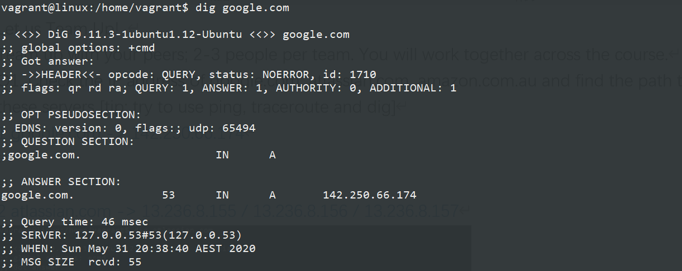

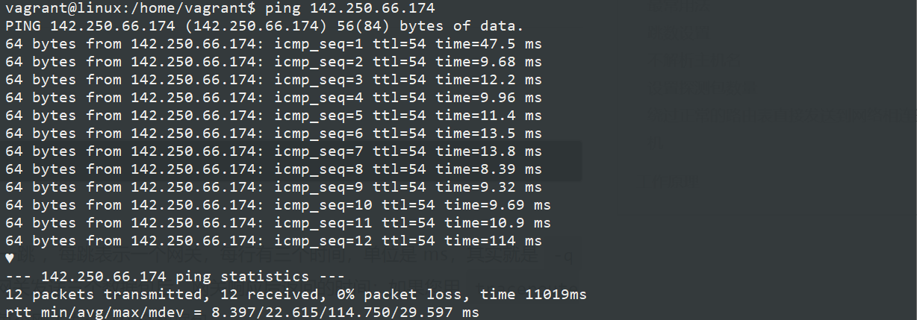

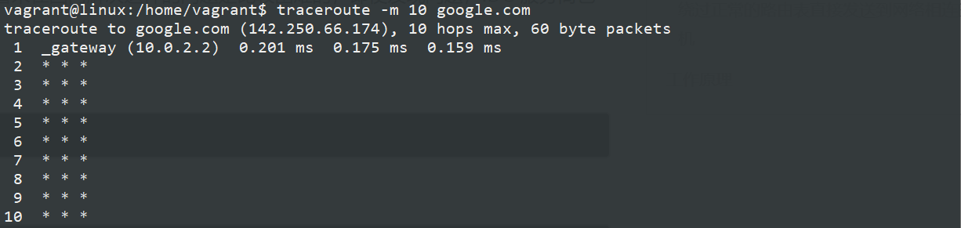

2 atlassian.com -> 13.236.8.155 / 13.236.8.156 / 13.236.8.157

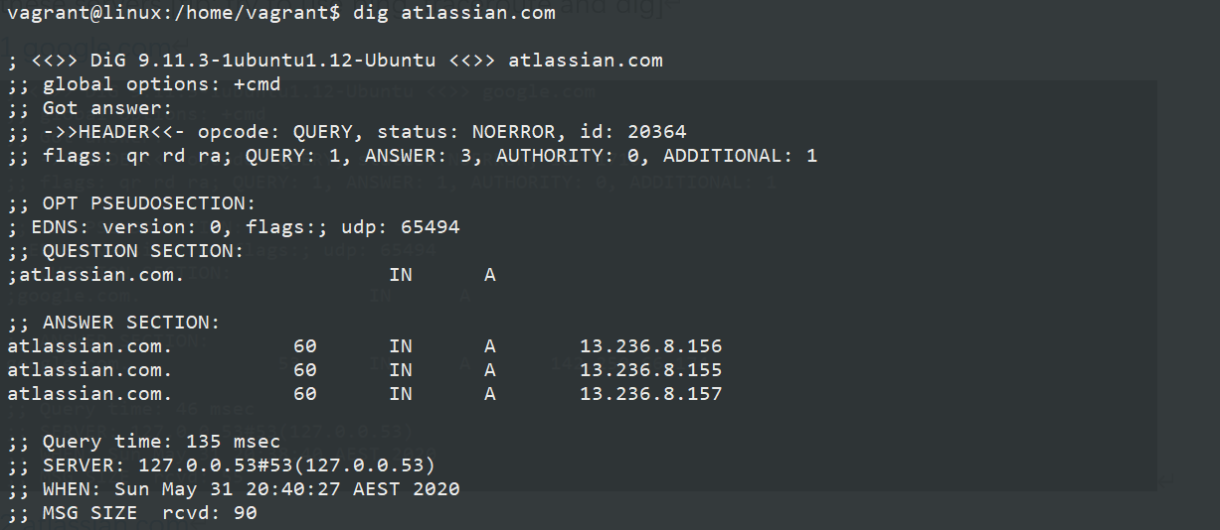

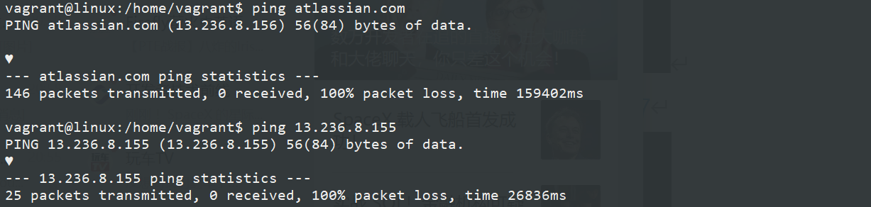

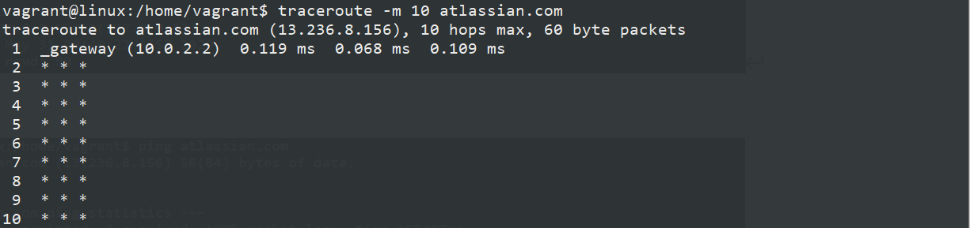

3 amazon.com.au -> 54.240.248.230 / 54.240.250.225 / 54.240.252.209

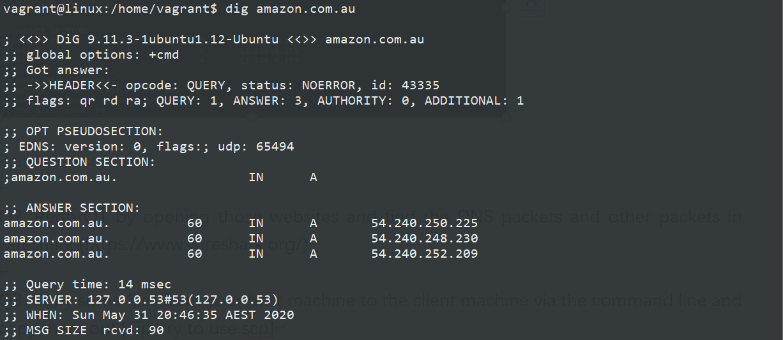

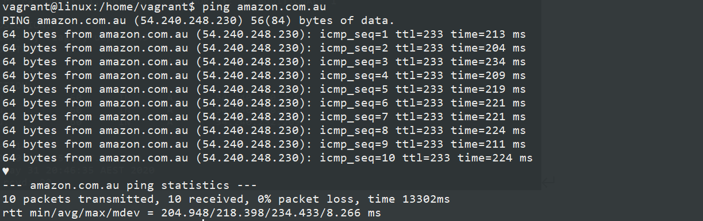

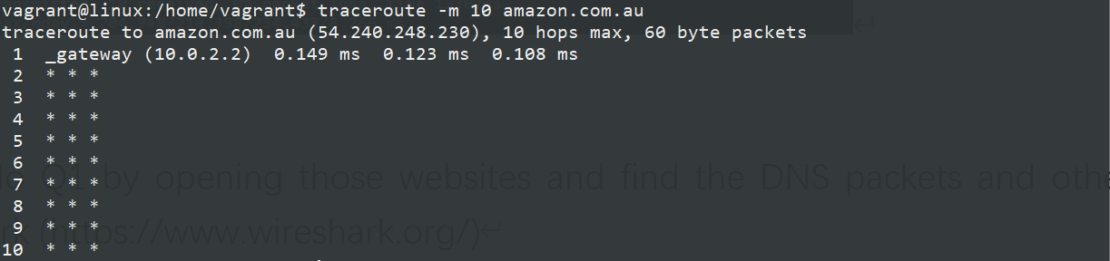

Q2. Redo Q1 by opening those websites and find the DNS packets and other packets in Wireshark (<https://www.wireshark.org/>)

1 google.com -> 142.250.66.174

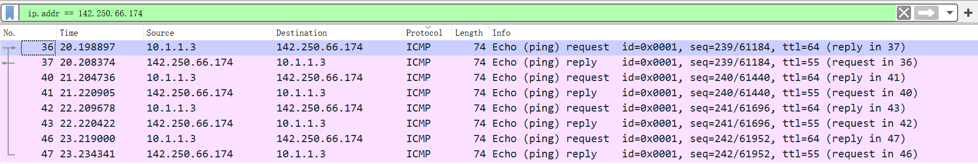

2 atlassian.com -> 13.236.8.155 / 13.236.8.156 / 13.236.8.157

3 amazon.com.au -> 54.240.248.230 / 54.240.250.225 / 54.240.252.209

Q3. Copy some files from your host machine to the client machine via the command line and copy them out [Tip: try to use scp]

$ vagrant scp <local_path> [vm_name]:<remote_path>

$ vagrant scp [vm_name]:<remote_path> <local_path>

1 Copy file to the client machine via the command line by using scp

$ vagrant scp Vagrantfile /home/vagrant

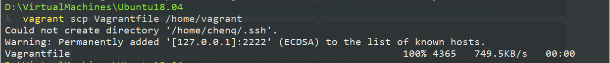

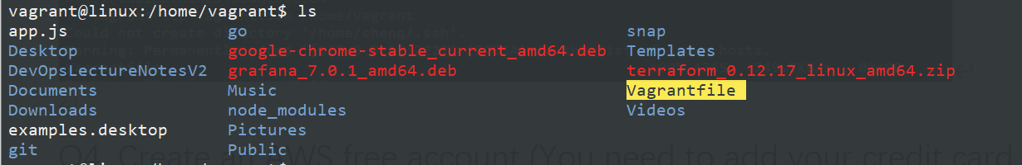

But it failed to copy the files in other directories to the client machine, just the files in some directory with Vagrantfile.



2 Copy out file from the client machine via the command line by using scp

$ vagrant scp :/home/vagrant/app.js app.js

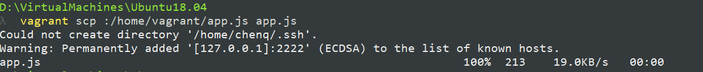

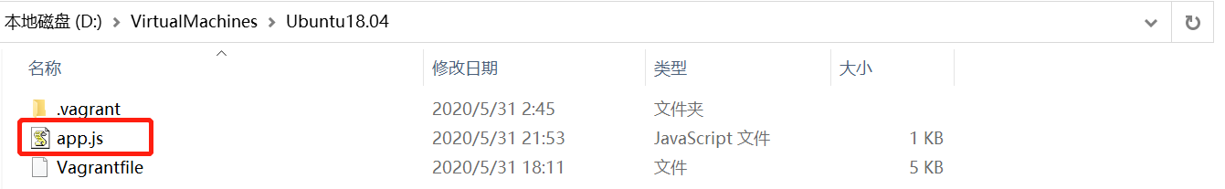

I tried to copy out the file to another disk, which is different from the disk the Vagrantfile is in, but the file was still copied to D:\.



Q4. Create an AWS free account (You need to add your credit card details) and try out AWS-CLI; upload, browse and upload files to S3.

<https://aws.amazon.com/>

ID: 680871926143

[chenqi830521@gmail.com](mailto:chenqi830521@gmail.com) Cq******

AWS Command Line Interface

$ aws configure

$ aws configure –profile default

$ aws s3 ls

$ aws s3 mk s3://xxx

$ aws s3 rb s3://xxx

$ aws s3 cp /xxx/xxx s3://xxx

$ aws s3 ls s3://xxx

$ aws s3 sync . s3://xxx

$ aws s3 sync /xxx/xxx s3://xxx

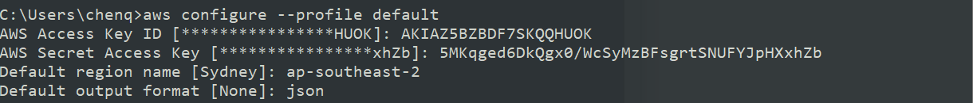

Upload-make bucket



Browse the bucket made and the files uploaded

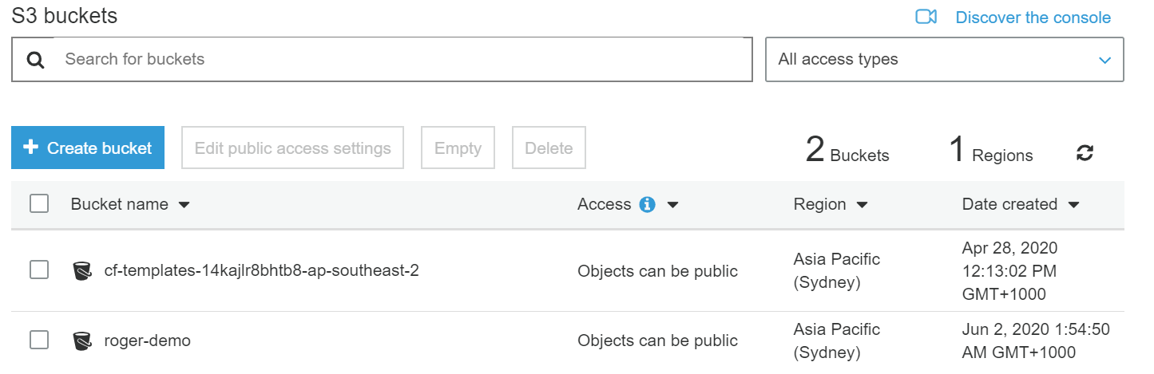

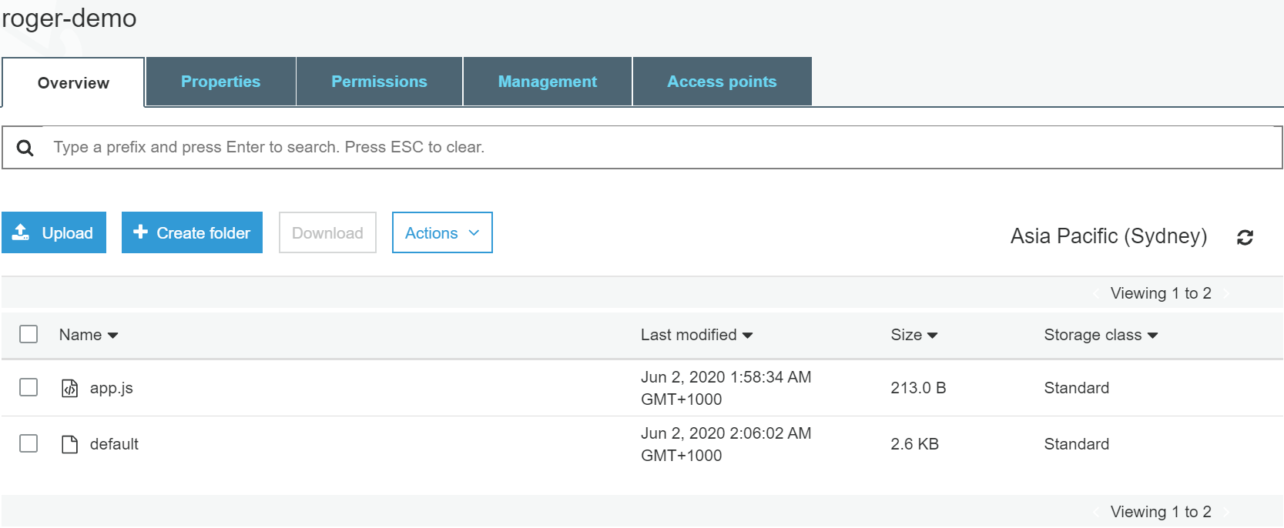

Upload files to S3

$ aws s3 cp app.js s3://roger-demo

$ aws s3 cp /etc/nginx/sites-availabel/default s3://roger-demo

$ aws s3 ls s3://roger-demo





Q5. Read through this tutorial about Nginx https://openresty.org/download/agentzh-nginx-tutorials-en.html and try out different settings. Share with the team what are the difference between Round Robin and Least Connection.

Simplified Chinese: <http://blog.sina.com.cn/s/blog_6d579ff40100y5p7.html>

Round Robin?

Least Connection ?

Q6. Find and use a load tester to load test the URLs. Note down how many requests per second (RPS) can Nginx handle. Does it match what Nginx claimed? Also, try to monitor the saturation of the Nginx server (CPU, memory, I/O etc...). Do you see any significant changes in those metrics?

Apache JMeter <https://jmeter.apache.org/>

Q7. Set up two servers: one with port 5555 and the other one with port 8888 and set up some URLs path and some default error pages. When accessing the correct URLs, expect the status code to return 200. Otherwise, show the error page.

Localhost:5555

Localhost:8888

## Pre-requisite to WK2 - Create an AWS account

1. Account creation

The account creation itself is free. We can use resources under free-tier for free up to 1 year. Please use the link below to create: https://aws.amazon.com/premiumsupport/knowledge-center/create-and-activate-aws-account/

2. Verify your account is working

Please verify that you can create an EC2 instance (Instance Type: t2.micro)

<https://aws.amazon.com/premiumsupport/knowledge-center/create-linux-instance/>

